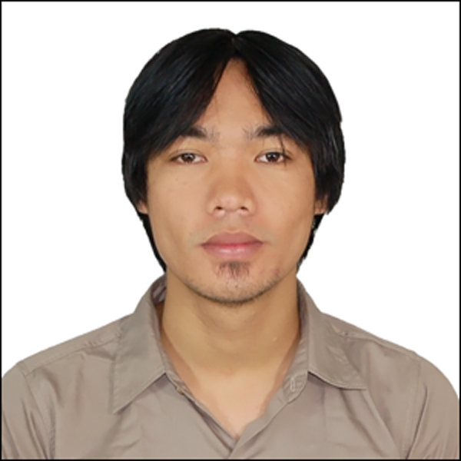

TERENCE C. SADANG

Pitogo, Consolacion
Cebu, 6001
09334647635
terence_sadang@yahoo.com

EDUCATION

2004-2006 STI MANDAUE
Diploma in Computer and Electronics Technology (DCET)

2000-2004 Consolacion National High School
High School Diploma

WORK EXPERIENCE

Jan 2012 to Present Signa Modena General Merchandise
[Printing / Publishing]
M.J. Cuenco Ave. Mabolo Cebu City 6000
Graphic Artist:
- design / layout logo, signages, billboards and tarpaulin using
[corel draw x5] [photoshop CS5] [illustrator] softwares
Printer Operator:
- print / plot set up large print format for tarpaulin and stickers using
[roland] [mimaki] [k-jet] printer machines
Laser Operator:
- cut / itch acrylic plastics, glass, granite stone using
[laser pro] laser machines

Feb 2007-Jan 2012 Innodata Knowledge Services, Inc.
[IT-Enabled Services / Business Process Outsourcing]
HVG Information Technology Park
Subangdaku, Mandaue City 6014
Cover Editor:
- revised old cover to look new again making replicate from one
hard copy to many soft copies produced, using [photoshop CS2]
Internal Layout:
- editing internal dirts page by page binding it as one, update new
ISBN barcodes, using [acrobat professional v.8] software
Scanner:
- scan book cover and internal pages for preparation of cover and
internal editing process, using [canon scanner] machines

TRAININGS / SEMINARS

July 2005 - Feb 2006 PRACTICUM TRAINEE,
STI MANDAUE, Computer Laboratory
Student Assistance:
- assist administrator for computer repairs both hardware and software
matters, especially maintaining network over 50+ desktop pc at laboratory
to install Operating System, update all softwares, protect from viruses
and save important back up files.

Jan 9-11 2006 Certificate of Training
STI MANDAUE, Computer Laboratory
Conducted by: Instructor / System Administrator Mr. Emmanuel Dacuba
During the trainings administered by the undersigned instructors,
the students demonstrated the following competencies:

- Computer Assembly
- Troubleshooting Hardware Problem
- Software Installation
- Computer Networking

PERSONAL INFORMATION

Age : 26
Gender : Male
Date of Birth : August 01, 1987
Place of Birth : Cebu City
Civil Status : Married
Weight : 59 kg
Height : 165 cm

REFERENCES
Hazelourd Retuya
Layout Designer, XLIBRIS PHIL., Inc.

Garing Consolacion Cebu
09294299275

Glen dela Rama
Production Associate, Innodata Knowledge Services, Inc.
Guinsay, Danao City
09069143822

Ronchun C. Villaester
Layout Designer, XLIBRIS PHIL., Inc.
Galaxy Compound Maguikay, Mandaue City
09099041882

